**How to Upload a File on Portal**

1. Login to Portal with your username and password.
2. Click on **File Uploader** page under **File Submission** tab

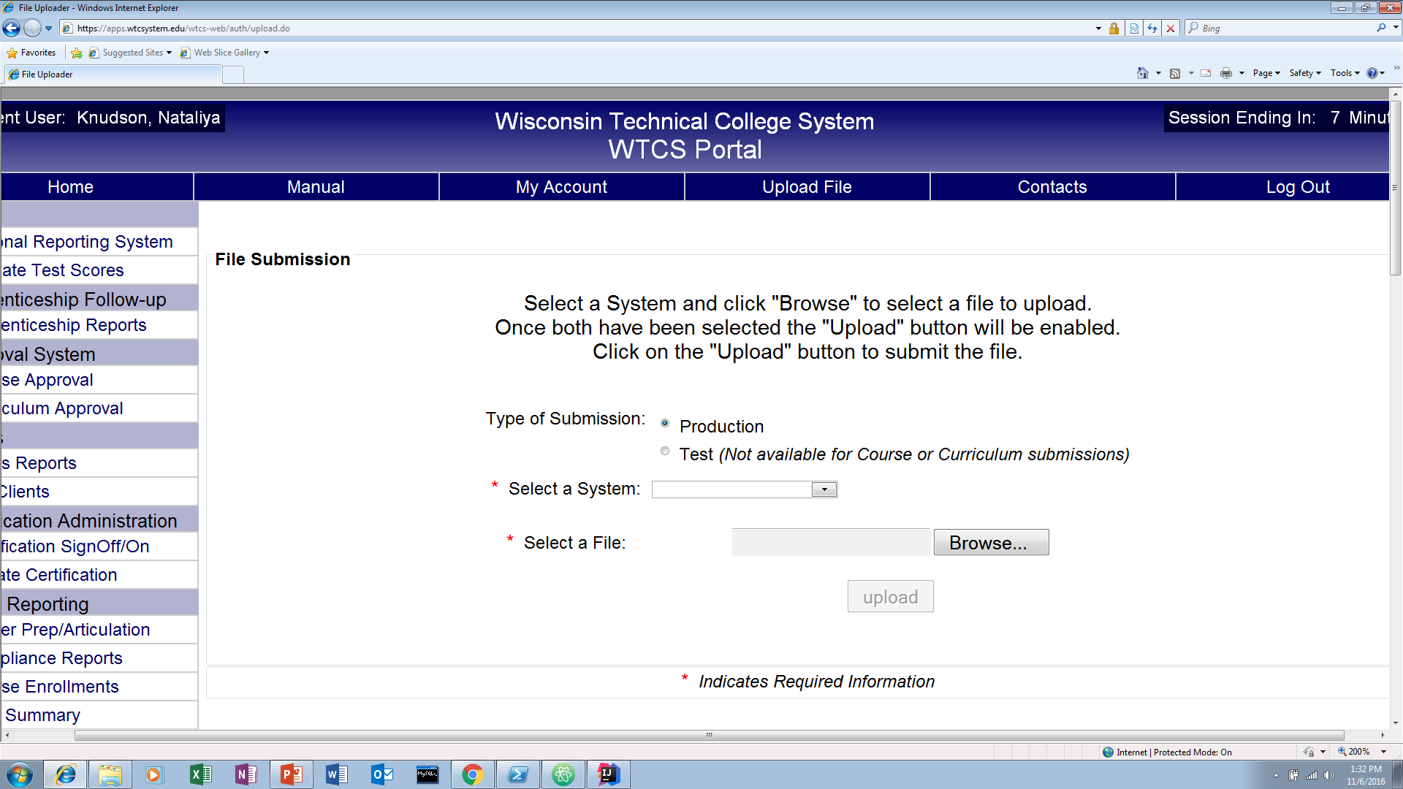

1. Select Client System from a dropdown list and then click **Browse…** to choose a file you want to upload.
2. You will be redirected to the **File Submission** page, where you can see the status of your file.

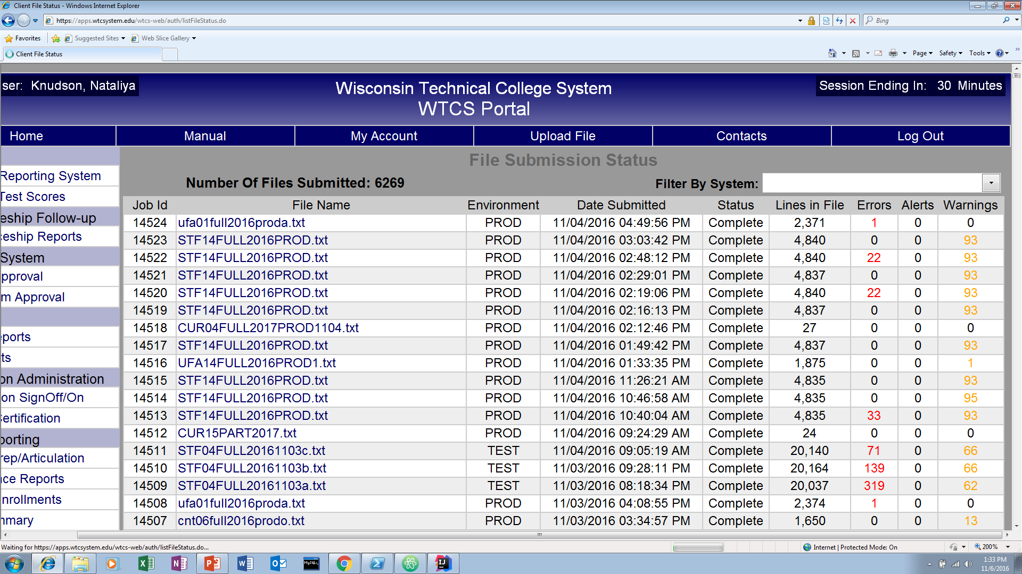

1. The web service will validate the data types in the submitted file. If the data type is not valid, you will receive a message that will notify you of the error and its location in the file.

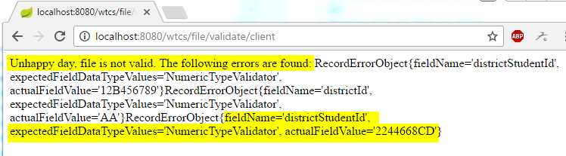

1. Fix the error and resubmit the file following steps 2-5.